Drop-in Clinics: days and times for January- April 2018:
The morning session runs between 10.00am-12noon. No booked time slot is required for this session.
A small number of bookable time slots are available from 1.00pm-2.30pm in each clinic. These can be booked by contacting the Speech and Language Therapy Department on 0141 314 4601.
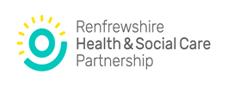

Speech & Language Therapy
Drop-in Advice Clinics
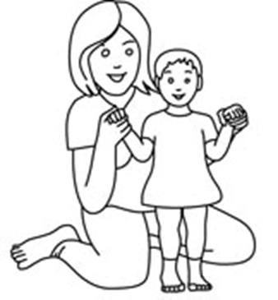
Foxbar Clinic  Morar Drive  Foxbar  PA2 9QR | 1st Monday of the month  No clinic in January 2018  5th February 2018  5th March 2018  No clinic in April 2018
Johnstone Health Centre  60 Quarry Street  Johnstone  PA5 8EY | 3rd Tuesday of the month  16th January 2018  20th February 2018  20th March 2018  17th April 2018
Erskine Health Centre  Bargarran Square  Erskine  PA8 6BS | 4th Wednesday of the month  24th January 2018  28th February 2018  28th March 2018  25th April 2018
Linwood Health Centre  5 Bridge Street  Linwood  PA5 3DB | Last Thursday of the month  25th January 2018  22nd February 2018  29th March 2018  26th April 2018
Aranthrue Centre  103 Paisley Road  Renfrew  PA4 8LH | 2nd Friday of the month  12th January 2018  9th February 2018  9th March 2018  13th April 2018

For Children & Families living in Renfrewshire

Speech & Language Therapy Department
0141 314 4601
What is a Speech and Language Therapy Drop-in Clinic?

The Drop-in Clinic is a session for parents/carers who want advice about their child’s speech and/or language development. You will have the opportunity to discuss your child’s development with a Speech and Language Therapist & Speech and Language Therapy Support Worker.

Your health visitor, GP or your child’s nursery/school may recommend that you visit our Drop-in Clinic. They are open to families who live in Renfrewshire.

No appointment or referral is required. It is a 'first come....first served' system, and you may have to wait to be seen. If the Drop-in Clinic is very busy, you may prefer to come back to the next scheduled session.

We have a limited number of bookable time slots which you can book by contacting the department on 0141 314 4601.
What will happen at the Drop-in Clinic?
We will ask you to tell us about your child’s speech, language and communication development.

We will give you advice on how to support your child to develop their speech, language and communication skills including tips to try at home or useful web sites to look at.

We may do a short evaluation of your child’s speech and language skills using simple screening checklists with you or we may do this by watching and joining in with your child in play activities.

We may agree the next step for your child, which might include a therapy home pack or a referral for a detailed assessment by a Speech and Language Therapist.

Clinics are held each month at clinics across Renfrewshire. You can attend any session with your child, no matter where you live Renfrewshire.

